Ajax framework Demo
Table of Contents
Ajax framework Demo 1
Purpose 2
Direction for use 2
Simple Introduction 3
Design 3
getService method 3
loadPageAsyn method 4
loadJS method 5

Purpose
- Easy to get data from web service
- Use Ajax
- Avoid duplicate javascript file download
- Verify the Infor Html5 Control useful for us

Direction for use
- Open solution file “ClinicalPortal.sln” in visual studio 2010.
- Find the “Default.html” file which is the entry of the site.
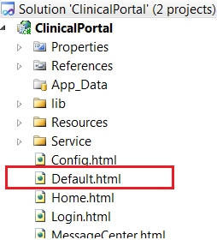
- Right click the “Default.html”, and click the “view in browser” menu.
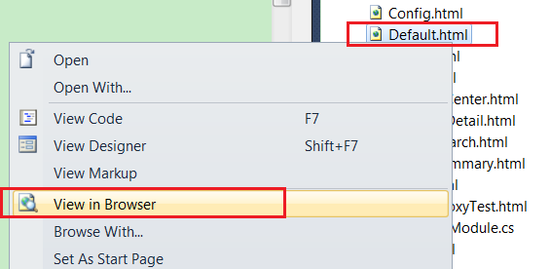
- Log in.
User/Password: admin/admin

Simple Introduction
- Prerequisite js files:
jquery-1.8.2.js, jquery-ui-1.9.0.custom.min.js, inforControlsCombined.js, json2.js
- Main js file: Resources/clinicalPortalFramework.js
- Web service file: Service/Service1.asmx
- Web site entry page: Default.html
- Log in user information storage: user.txt

Design

getService method

Api
getService (webServiceUrl) Return: service object.

Sample
var service1Obj = cp.getService("Service/Service1.asmx");
var menuData = service1Obj.GetMenu();

UML
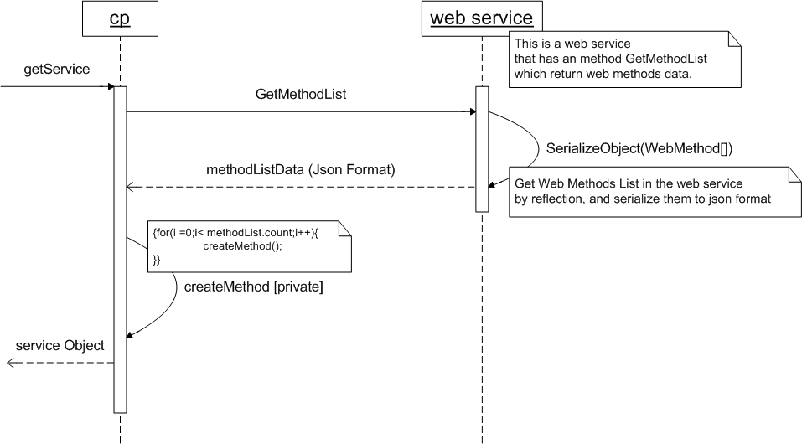

loadPageAsyn method

Api
loadPageAsyn (url, [, contentHolderId] [, storeInHistory] [, successFn])

Sample
cp.loadPageAsyn("Home.html");
cp.loadPageAsyn("Home.html", "configContent");

UML
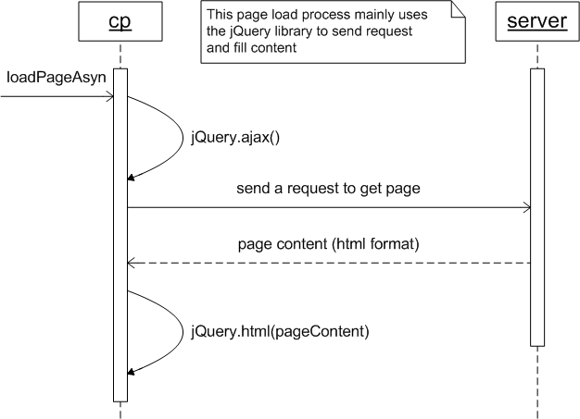

loadJS method

Api
loadJS (url [, alwaysServer])

Sample
explicitly use:
<script type="text/javascript">cp.loadJS("Resources/user.js");</script>
implicitly use:
We add the js reference in the html page just as usually as we do:
<script type="text/javascript" src="Resources/user.js"></script>
After the page content which contains the above script tag was downloaded, the script tag will be replaced with the script tag below:
<script type="text/javascript">cp.loadJS("Resources/user.js");</script>

UML
